Contacts:  Lyn Mayes, The Packaging Forum  Phone 021 471 261; lynmayes@madworld.co.nz  Andrew Hewett, Chair Public Place Recycling Scheme 021629106 andrew.hewett@ccamatil.com |  | 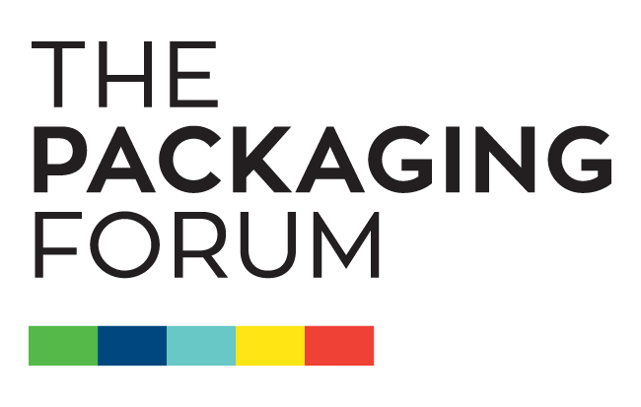

Press Release

Packaging Forum launches new initiative to recycle soft plastic packaging

A new initiative to introduce recycling bins so that shoppers can take back their used soft plastic bags to supermarkets and retail premises was announced today by The Packaging Forum.

The project will initially trial at New World, PAK’nSAVE and The Warehouse stores in Auckland before rolling out to Countdown stores in Hamilton with further expansion to Wellington, Canterbury, Otago, Bay of Plenty, Manawatu and other regions over three years. The objective is to provide access to recycling for soft plastics for over 70% New Zealanders.

Lyn Mayes, Manager of the Public Place Recycling Scheme which will manage the project said:

“Soft plastic bags are not currently collected for recycling by councils because they can contaminate the recycling process. New Zealanders use over 1.6 billion plastic bags in the home every year. The new project will take all soft plastic bags including bread bags, frozen food bags, toilet paper packaging, confectionery and biscuit wrap, chip bags, pasta and rice bags, courier envelopes, shopping bags, sanitary hygiene packaging- basically anything made of plastic which can be scrunched into a ball.

Customers can bring their used soft plastics back to store and put them in the recycling bin. This will be collected from store by REDcycle who also run the programme in Australia. Initially the materials will be sent back to Australia where they are made into park benches and fitness circuits for playgrounds until there are facilities in NZ such as those planned at Astron Plastics that can process these products. One of the really great opportunities is to make recycling bins out of these soft plastics so we can buy them back for our Public Place Recycling Scheme. We expect the first new specially designed REDcycle bins to be in participating Auckland stores by the end of September.”

Andrew Hewett, Chair of The Public Place Recycling Scheme said:-

“This project shows what can be achieved by industry working in partnership with Central Government. The Public Place Recycling Scheme is focused on increasing recycling away from home and reducing litter and this project goes one step further by providing households with the opportunity to take their soft plastic bags back when they go shopping and providing a cost-effective recycling solution for the wide range of soft plastic packaging which every household uses.
This is a voluntary, industry-led initiative and a true product stewardship model where everyone involved in the life cycle of a product – manufacturers, distributors and consumers – choose to share responsibility for the best end-of-life outcome.”

The project is already supported by major brands including Cottonsoft, Goodman Fielder, Huggies, Kleenex, New Zealand Post, Pams, SunRice, Astron and Elldex Plastics with many others committed to joining the programme.

Shoppers in Australia and in the UK have demonstrated that collecting soft plastic packaging and dropping it off at a collection point is simple and effective. A survey of New Zealanders by Horizon Research in June found that 61% respondents would take their soft plastic bags back to a drop off recycling bin at supermarkets and other locations if this service were provided; and 78% would be likely to use this service if they knew that the soft plastic bags would be made into useful products such as park benches, recycling bins or fitness circuits.

ENDS…

For Information

The REDcycle Program is a supermarket-based recycling program that invites consumers to gather together all their single-use shopping bags, as well as food and grocery packaging that isn’t able to be recovered via kerbside collection, and take them to their nearest supermarket drop off point next time they visit. The collected soft plastic material is used as the resource to manufacture new recycled-plastic items such as sturdy outdoor furniture, signage and traffic control products suitable for use in schools, parks and other public spaces. The program was launched in Australia in 2012, and now has drop off points in around 580 supermarkets.
Horizon Research surveyed 1627 respondents nationwide between 16th June and 26th June 2015.
Respondents are members of the HorizonPoll online panel, recruited to match the New Zealand population aged 18+.

