Horizon Research

Human rights and Te Tiriti/ Treaty issues
December 2025

Prepared for

Te Kāhui Tika Tangata
Human Rights Commission

Contents
Executive Summary 3
Summary of findings 3
Report 7
How well informed do people feel about the Treaty of Waitangi/ Te Tiriti o Waitangi and the issues being debated? 8
New Zealand’s Constitutional arrangements 10
Awareness of the Treaty/Te Tiriti and Human Rights 12
Views on current the Treaty/Te Tiriti debates 16
Who to trust to provide accurate information about the Treaty/Te Tiriti 19
What is important for the country? 23
Aspirations for future of Aotearoa New Zealand? 29
Born in New Zealand 30
Appendix – Methodology and Sample 32

Executive Summary

This report summarises the results of a survey of New Zealand adults’ views and understanding of the Treaty of Waitangi/ Te Tiriti o Waitangi, and how it should be honoured.
It also finds what is most important for the future of the country when managing Treaty/ Te Tiriti issues.
The research aims to support work to educate, protect human rights and foster understanding of Treaty of Waitangi/ Te Tiriti o Waitangi.
The survey was conducted nationwide between 12th and 21st December 2025. There were 1,079 respondents aged 18+, representing New Zealand’s adult population.
At a 95% confidence level, the survey has a maximum margin of error of ±3% overall.
Some results in this report are compared with results of surveys conducted for Te Kāhui Tika Tangata, the Human Rights Commission, in November 2023 and December 2024.

Summary of findings

What is important for the country?
A country in which a strong sense of belonging and human rights are respected, upheld and protected in New Zealand’s laws and constitutions are all considered important.

93% believe Everyone in New Zealand having a strong sense of belonging is important. This is the equivalent of around 3,595,000 adults.
- 70% (2,686,000 adults) say it is very important.
92.9% (3,590,000 adults) believe that a country where human rights are respected and upheld is important.
- 76% (2,941,000 adults) believe it is very important.
91% (3,513,000 adults) also believe Human rights being protected in New Zealand’s laws and constitution is important.
- 68% of New Zealand adults (2,617,000) believe it is very important.

Aspirations for Aotearoa New Zealand
Respondents were asked to say in their own words what their aspirations are for the future of Aotearoa New Zealand. Of the 934 responses many aspired for a more united and cohesive country. Some expressed concern about a divide and wanted everyone to move forward together.
There were also mentions of support for the Treaty/Te Tiriti and the need to honour it but also for some there were concerns about the division which has been created.
Many also want to see the economy get better and people have access to quality services like education and health.

Respondents’ views of the Treaty/Te Tiriti
Agreement with some statements about the Treaty/ Te Tiriti has dropped slightly since 2024.
The only statistically significant decline was the number who agree that Working through Treaty/ Te Tiriti issues requires more careful listening and understanding and less political rhetoric – down from 68% in 2024 to 63% (2,420,000 adults).
Total agree | 2025 | 2024
The signing of the Treaty / Te Tiriti is a significant event in New Zealand’s history and an important part of our national identity. | 71% | 73%
By enabling non-Māori to settle peacefully in this country, the Treaty / Te Tiriti is a document that supports belonging for everyone in New Zealand. | 64% | 67%
Working through Treaty/ Te Tiriti issues requires more careful listening and understanding and less political rhetoric. | 63%â | 68%
The spirit and intent of the Treaty/Te Tiriti can help guide us in how we move forward as a country from here. | 55% | 57%
↑↓ Significant change from 2024.

Although the number who agree with the statements has seen a slight drop there is a significant increase in those who disagree with them.
The statement Working through Treaty/ Te Tiriti issues requires more careful listening and understanding and less political rhetoric had the biggest increase from 11% in 2024 to 18% who disagree (707,000 adults) in 2025.
Total disagree | 2025 | 2024
The signing of the Treaty / Te Tiriti is a significant event in New Zealand’s history and an important part of our national identity. | 14%á | 9%
By enabling non-Māori to settle peacefully in this country, the Treaty / Te Tiriti is a document that supports belonging for everyone in New Zealand. | 16%á | 10%
Working through Treaty/ Te Tiriti issues requires more careful listening and understanding and less political rhetoric. | 18%á | 11%
The spirit and intent of the Treaty/Te Tiriti can help guide us in how we move forward as a country from here. | 23%á | 17%
↑↓ Significant change from 2024.

The Treaty of Waitangi/ Te Tiriti o Waitangi awareness
There is a continued increase in the number of people who feel informed about Te Tiriti/the Treaty and the issues being debated about how it should be honoured.
86% (3,309,000 adults) believe they are informed. A significant increase from 72% in 2024 and 58% in 2023.
Being informed about constitutional arrangements has also increased significantly from 61% to 68% (2,640,000 adults) who say they feel informed about the constitutional arrangements in New Zealand.
Awareness of the Treaty/Te Tiriti and Human Rights
94% (3,614,000 adults) are aware that A treaty is an agreement between nations.
89% (3,440,000 adults) said they are aware that The right to self-determination is a fundamental human right.
88% (3,382,000 adults) are aware that the Treaty/Te Tiriti relates to people’s human rights in Aotearoa/New Zealand.
At 72% (2,771,000 adults), lowest awareness was for The tino rangatiratanga that was guaranteed to Māori in Te Tiriti aligns closely with the human right to self-determination.

Trusted Sources
The five most trusted sources to provide accurate information about the Treaty/Te Tiriti are:
- The Waitangi Tribunal – 45%, up from 41% in 2024
- The National Library of New Zealand – 36%, a significant drop from 44%
- Books, websites, podcasts, etc that cover New Zealand history – 33%
- Te Kāhui Tika Tangata Human Rights Commission – 31% slightly up from 29% in 2024
- People associated with educational institutions – 24%.
The least trusted sources are:
- Social media - 6%
- Political parties –7%
- Members of Parliament – 7% significantly down from 10% in 2024
- English Language news media – 8% significantly down from 13% in 2024.
17% do not trust any information sources.

Report

Before starting the survey, respondents were told:
The Treaty of Waitangi / Te Tiriti o Waitangi was an agreement between Māori leaders and the British Crown in 1840. As New Zealand has evolved, the Crown has come to be represented by the New Zealand government and represents not only British settlers or Pākehā New Zealanders, but all the many peoples who call Aotearoa New Zealand home.
The signing of the Treaty / Te Tiriti allowed non-Māori settlers, a small minority population at the time, to settle peacefully and to create a governance system for themselves.
The Treaty / Te Tiriti also assured the majority Māori population that their way of life would continue and guaranteed that the things that are important to Māori and distinctive about Māori culture and life would be protected. This included that Māori would keep their existing authority and ability to make decisions for themselves, their tino rangatiratanga. In human rights terms, this is known as the right to self-determination.
Historians and experts, both Māori and non-Māori, say that all parties involved in the creating and signing of the Treaty/ Te Tiriti intended us to move forward together as a country while caring for and protecting each group’s unique needs and differences.
Although the Crown has acknowledged it has repeatedly breached the agreement, Māori and other New Zealanders have turned to the Treaty/ Te Tiriti – for instance, through the Waitangi Tribunal and international human rights bodies – to make sure that the government acts as they agreed.

How well informed do people feel about the Treaty of Waitangi/ Te Tiriti o Waitangi and the issues being debated?
The number feeling informed about Te Tiriti/the Treaty and the issues being debated about how it should be honoured continues to increase.
86% (3,309,000 adults) believe they are informed. This is a significant increase from 72% in 2024 and 58% in 2023.
- 13% believe they are very well informed
- 29% say they are well informed, which is a significant increase from 23% in 2024.
Total uninformed*
2025: 12%á
2024: 9%
2023: 21%
Total informed
2025: 86%á
2024: 72%
2023: 58%
Total Sample: 2025 n=1,079; 2024 n=1,043; 2023 n=1,074
↑↓ Significant change from 2024.
* Total uninformed NETT = Totally uninformed/uninformed. “Somewhat uninformed” was not in 2025 survey.

The table below shows the differences across groups who feel they are informed or uninformed about the Te Tiriti/the Treaty and the issues currently being debated.
More likely feel informed about Te Tiriti/the Treaty  Total 86% |  | More likely feel uninformed about Te Tiriti/the Treaty  Total 12%
55+ year olds  Other European ethnicity  Household income $50k-$70k  Household income $150k+ | 93%  93%  92%  95% | 35-44 year olds  Household income $20k-$30k  Household income $70k-$100k  Single person household | 21%  31%  19%  20%

New Zealand’s Constitutional arrangements

Respondents were told:
A constitution is a set of rules that a community sets about how it is governed. It includes things like: how rules will be made, by who, and how people are to abide by those rules. Constitutions can set out the powers and duties of governments and can provide protections for people’s rights.
New Zealand has no single constitution. Instead our constitution includes a range of formal legal documents (like the New Zealand Bill of Rights Act 1990), decisions of the courts, and practices. Te Tiriti / the Treaty is regarded as a founding document of the government in New Zealand and as part of the constitution.
Being informed about constitutional arrangements has increased significantly with 68% (2,640,000 adults) saying they feel informed about the constitutional arrangements in New Zealand.
- 10% (398,000 adults) feel very well informed, a significant increase from 7% in 2024.
27% (1,059,000 adults) feel they are uninformed about the constitutional arrangements, a significant decrease from 31% in 2024.
The number who are unsure is 4% (139,000 adults), a significant drop from 7%.

Total informed
2025: 68%á
2024: 61%
Total uninformed
2025: 27%â
2024: 31%
Total Sample: 2025 n=1,079; 2024 n=1,043
↑↓ Significant change from 2024.

The table below shows the differences across groups who feel they are informed or uninformed about constitutional arrangements in New Zealand.
More likely feel informed about constitutional arrangements in New Zealand.  Total 68% |  | More likely feel uninformed about constitutional arrangements in New Zealand. Total 27%
55-64 year olds  65-74 year olds  Household income $50k-$70k  Household income $100k-$150k  Household income $150k+  Couple only (no children/ none at home)  Living with extended family | 77%  83%  76%  76%  76%  79%  80% | 25-34 year olds  Asian  Pasifika  Living in Canterbury | 41%  38%  44%  37%

Awareness of the Treaty/Te Tiriti and Human Rights

Respondents were shown thirteen statements and asked about their awareness of them. Overall, awareness of all statements was high.
80% or more were aware of six of the statements.
Highest awareness was A treaty is an agreement between nations. 94% (3,614,000 adults) said they were aware and 3% (100,000 adults) not at all aware
89% (3,440,000 adults) are aware that The right to self-determination is a fundamental human right.
88% (3,382,000 adults) are aware that the Treaty/Te Tiriti relates to people’s human rights in Aotearoa/New Zealand.

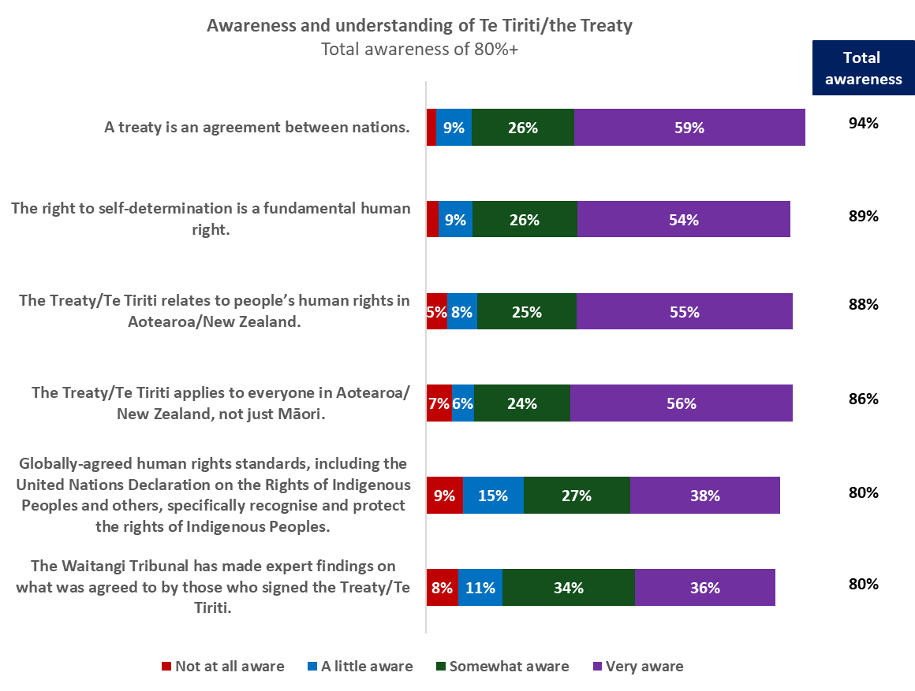
Total Sample: n=1,079

Lowest awareness was for The tino rangatiratanga that was guaranteed to Māori in Te Tiriti aligns closely with the human right to self-determination. 72% (2,771,000 adults) are aware and 13% (506,000 adults) are not at all aware.

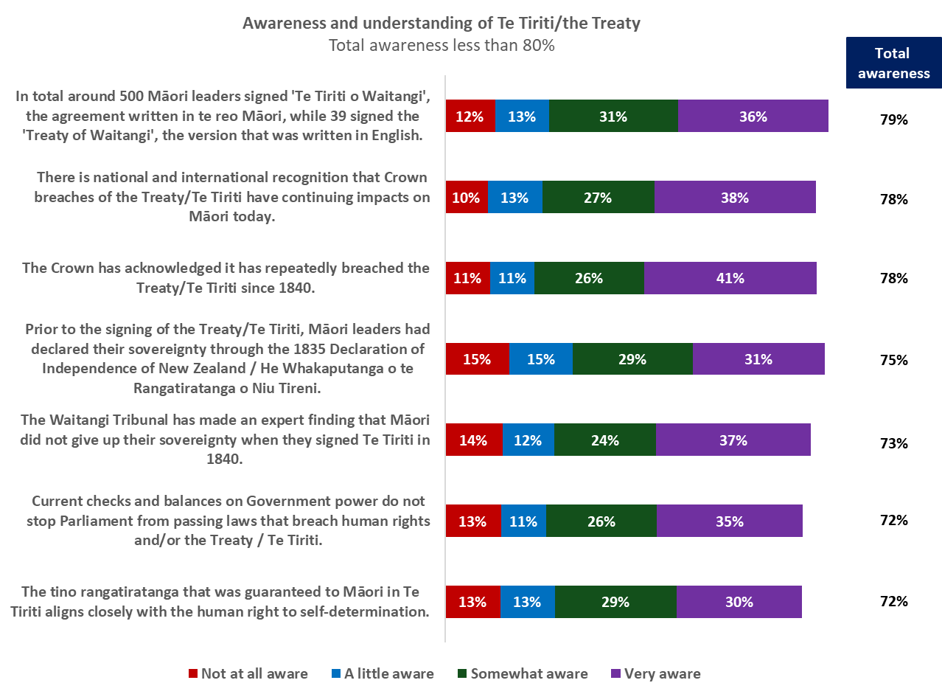
Total Sample: n=1,079

The table below shows significant differences across groups who are aware of each of the statements.
Are you aware of the following? | Total aware | Significantly more likely to be awarep
A treaty is an agreement between nations. | 94% | 75+ year olds  Single person household | 99%  98%
The right to self-determination is a fundamental human right. | 89% | 75+ year olds  Asian  Other European  Annual household income $100k-$150k  Annual household income $150k+ | 94%  94%  96%  95%  95%
The Treaty/Te Tiriti relates to people’s human rights in Aotearoa/New Zealand. | 88% | 75+ year olds  Females  Other European  Living in South Island  Annual household income $50-$70k  Annual household income $50-$150k  Couple only (no children at home) | 94%  91%  95%  92%  93%  93%  91%
The Treaty/Te Tiriti applies to everyone in Aotearoa/ New Zealand, not just Māori. | 86% | 75+ year olds  Other European  Annual household income $50-$150k  Annual household income $150k+  Couple only (no children at home)  Flatting or boarding - not a family home | 94%  96%  90%  95%  90%  94%
Globally-agreed human rights standards, including the United Nations Declaration on the Rights of Indigenous Peoples and others, specifically recognise and protect the rights of Indigenous Peoples. | 80% | Māori  Other European  Annual household income $100k-$150k  Annual household income $150k+ | 86%  96%  94%  88%
The Waitangi Tribunal has made expert findings on what was agreed to by those who signed the Treaty/Te Tiriti. | 80% | Other European  Annual household income $50-$150k  Extended family | 96%  86%  89%
In total around 500 Māori leaders signed 'Te Tiriti o Waitangi', the agreement written in te reo Māori, while 39 signed the 'Treaty of Waitangi', the version that was written in English. | 79% | 18-24 year olds  65-74 year olds  Other European  Living in South Island  Annual household income $150k+  Couple only (no children at home) | 87%  87%  89%  87%  87%  85%
There is national and international recognition that Crown breaches of the Treaty/Te Tiriti have continuing impacts on Māori today. | 78% | Māori  Other European  Living in South Island  Annual household income $100k-$150k  Flatting or boarding - not a family home | 86%  93%  85%  89%  87%
The Crown has acknowledged it has repeatedly breached the Treaty/Te Tiriti since 1840. | 78% | 65-74 year olds  Other European  Living in Lower North Island  Living in Wellington  Living in Gisborne/Hawkes Bay  Annual household income $100k-$150k  Annual household income $150k-$200k  Couple only (no children at home) | 85%  96%  85%  85%  94%  87%  86%  83%
Are you aware of the following? | Total aware | Significantly more likely to be awarep
Prior to the signing of the Treaty/Te Tiriti, Māori leaders had declared their sovereignty through the 1835 Declaration of Independence of New Zealand / He Whakaputanga o te Rangatiratanga o Niu Tireni. | 75% | 18-24 year olds  Māori  Other European  Living in South Island  Annual household income $100k-$150k  Annual household income $150k+ | 86%  84%  88%  83%  83%  86%
The Waitangi Tribunal has made an expert finding that Māori did not give up their sovereignty when they signed Te Tiriti in 1840. | 73% | 18-24 year olds  Māori  Other European  Annual household income $100k-$150k  Annual household income $150k+ | 84%  84%  86%  82%  81%
Current checks and balances on Government power do not stop Parliament from passing laws that breach human rights and/or the Treaty / Te Tiriti. | 72% | 18-24 year olds  Māori  Pasifika  Annual household income $100k-$150k  Annual household income $150k+  Extended family | 80%  82%  84%  85%  80%  84%
The tino rangatiratanga that was guaranteed to Māori in Te Tiriti aligns closely with the human right to self-determination. | 72% | 18-24 year olds  Māori  Annual household income $100k-$150k  Annual household income $150k+  Flatting or boarding - not a family home | 81%  86%  82%  82%  82%

Views on current the Treaty/Te Tiriti debates
Respondents were shown a number of statements about the Treaty/Te Tiriti and asked if they agreed or disagreed with them. Since 2024 there have been some drops in those who agree with the statements.
71% (2,766,000 adults) agreed that The signing of the Treaty / Te Tiriti is a significant event in New Zealand’s history and an important part of our national identity. A slight drop from 73% in 2024.
There has been a significant drop from 68% to 63% (2,420,000 adults) who agree that Working through Treaty/ Te Tiriti issues requires more careful listening and understanding and less political rhetoric.

Total Sample: 2025 n=1,079; 2024 n=1,043
↑↓ Significant change from 2024.

Although the number who agree with the statements has seen a slight drop since 2024, there has been a significant increase in those who disagree with them.
Working through Treaty/ Te Tiriti issues requires more careful listening and understanding and less political rhetoric has the biggest increase from 11% in 2024 to 18% (707,000 adults) who disagree in 2025.

Total Sample: 2025 n=1,079; 2024 n=1,043
↑↓ Significant change from 2024.

Agreement with statements about the Treaty/Te Tiriti varies across different demographic groups.
 | Significantly more likely to agree p |  | Significantly more likely to disagree p
The signing of the Treaty / Te Tiriti is a significant event in New Zealand’s history and an important part of our national identity. | 55-64 year olds  Females  Other European  Living in Waikato  Living in Wellington  Annual household income $100k-$150k  Annual household income $150k-$200k  Flatting or boarding - not a family home | 79%  76%  83%  80%  84%  81%  80%  83% | Annual household income $20k-$30k | 25%
By enabling non-Māori to settle peacefully in this country, the Treaty / Te Tiriti is a document that supports belonging for everyone in New Zealand. | 65-74 year olds  75+ year olds  Living in Waikato  Living in Gisborne/Hawkes Bay  Annual household income $100k-$150k | 77%  75%  76%  80%  71% | Living in Canterbury  Annual household income $20k-$30k  Two parent family, three or more children at home | 24%  33%  28%
Working through Treaty/ Te Tiriti issues requires more careful listening and understanding and less political rhetoric. | Living in Gisborne/Hawkes Bay  Living in Wellington  Annual household income $100k-$150k  Flatting or boarding - not a family home | 75%  72%  71%  75% | Annual household income $200k+ | 29%
The spirit and intent of the Treaty/Te Tiriti can help guide us in how we move forward as a country from here. | 65-74 year olds  Māori  Living in Wellington  Annual household income $150k-$200k | 64%  63%  65%  65% | Two parent family, three or more children at home  Extended family | 36%  36%

Who to trust to provide accurate information about the Treaty/Te Tiriti
Respondents were shown a list of sources and asked to select all of those they would trust to provide accurate information about the Treaty/Te Tiriti.
The most trusted source is The Waitangi Tribunal, with 45% saying they trusted it to provide them with accurate information.
The National Library of New Zealand was the most trusted source; however, it has dropped significantly from 44% to 36%
Other most trusted sources of accurate information are:
- Books, websites, podcasts, etc that cover New Zealand history – 33%
- Te Kāhui Tika Tangata Human Rights Commission – 31% slightly up from 29% in 2024
- People associated with educational institutions – 24%.
The least trusted sources are:
- Social media - 6%
- Political parties –7%
- Members of Parliament – 7% significantly down from 10% in 2024
- English Language news media – 8% significantly down from 13% in 2024.
This year’s survey included the option Do not trust any information sources. 17% said they do not trust any sources.

Total Sample: 2025 n=1,079; 2024 n=1,042; 2023 n=1,072
↑↓ Significant change from 2024.

Overall, there is similar support for the top five trusted sources across all age groups.
There are some differences among under 35s, with 18-24 year olds more likely to trust
- Māori language news media: 27%
- Friends or family: 24%
- Political parties: 14%
- Social media: 13%.
25-34 year olds are more likely to trust
- Māori language news media: 23%
- Social media: 12%.
35-44 year olds are more likely to trust
- Government departments: 26%
- Friends or family: 20%.
Who would you trust to provide you with accurate information about the Treaty/Te Tiriti? | ALL | AGE
 | ALL | 18-24 years | 25-34 years | 35-44 years | 45-54 years | 55-64 years | 65-74 years | 75+ years
The Waitangi Tribunal | 45% | 38% | 49% | 43% | 45% | 46% | 47% | 44%
The National Library of New Zealand | 36% | 22% | 34% | 29% | 40% | 45% | 40% | 42%
Books, websites, podcasts, etc that cover New Zealand history | 33% | 31% | 32% | 25% | 29% | 33% | 39% | 52%
Te Kāhui Tika Tangata Human Rights Commission | 31% | 28% | 23% | 29% | 35% | 41% | 37% | 29%
People associated with educational institutions | 24% | 21% | 27% | 26% | 26% | 24% | 25% | 16%
National Iwi Chairs Forum | 19% | 22% | 12% | 14% | 22% | 25% | 21% | 20%
Māori-language news media | 17% | 27% | 23% | 13% | 17% | 14% | 14% | 7%
Government departments | 16% | 13% | 20% | 26% | 19% | 9% | 10% | 8%
Non-governmental organisations | 14% | 8% | 16% | 11% | 17% | 17% | 15% | 13%
Friends or family | 12% | 24% | 13% | 20% | 10% | 4% | 5% | 4%
Advocacy/activist groups or organisations | 10% | 6% | 12% | 12% | 14% | 6% | 9% | 5%
English-language news media | 8% | 8% | 7% | 11% | 8% | 7% | 10% | 5%
Members of Parliament | 7% | 10% | 11% | 9% | 7% | 2% | 5% | 6%
Political parties | 7% | 14% | 8% | 7% | 7% | 4% | 2% | 4%
Social media | 6% | 13% | 12% | 9% | 4% | 2% | 1% | 0%
Other | 6% | 3% | 2% | 5% | 5% | 13% | 11% | 4%
Do not trust any information sources | 17% | 17% | 10% | 13% | 21% | 20% | 20% | 20%
N (unweighted) | 1,079 | 118 | 186 | 192 | 174 | 167 | 136 | 106
BLUE = significantly higher than total sample RED =significantly lower than total sample
Top 5 trusted source for each group

Trusted sources vary for some ethnic groups.
Who would you trust to provide you with accurate information about the Treaty/Te Tiriti? | ALL | ETHNIC GROUP
 | ALL | Asian | Indian | Māori | NZ European/ Pākehā | Other European | Pasifika
The Waitangi Tribunal | 45% | 39% | 37% | 55% | 46% | 52% | 57%
The National Library of New Zealand | 36% | 30% | 41% | 30% | 39% | 25% | 32%
Books, websites, podcasts, etc that cover New Zealand history | 33% | 24% | 21% | 29% | 35% | 38% | 32%
Te Kāhui Tika Tangata Human Rights Commission | 31% | 25% | 15% | 43% | 32% | 39% | 45%
People associated with educational institutions | 24% | 21% | 25% | 30% | 25% | 23% | 25%
National Iwi Chairs Forum | 19% | 9% | 18% | 27% | 19% | 23% | 30%
Māori-language news media | 17% | 16% | 16% | 31% | 15% | 8% | 33%
Government departments | 16% | 35% | 34% | 10% | 15% | 8% | 16%
Non-governmental organisations | 14% | 14% | 20% | 15% | 13% | 13% | 13%
Friends or family | 12% | 15% | 14% | 22% | 10% | 6% | 27%
Advocacy/activist groups or organisations | 10% | 10% | 11% | 12% | 8% | 6% | 20%
English-language news media | 8% | 12% | 12% | 5% | 8% | 4% | 11%
Members of Parliament | 7% | 11% | 14% | 5% | 7% | 1% | 9%
Political parties | 7% | 9% | 7% | 10% | 6% | 1% | 10%
Social media | 6% | 13% | 17% | 11% | 4% | 7% | 5%
Other | 6% | 3% | 4% | 7% | 18% | 20% | 7%
Do not trust any information sources | 17% | 13% | 14% | 11% | 7% | 7% | 9%
N (unweighted) | 1,079 | 115 | 44 | 191 | 683 | 64 | 68
BLUE = significantly higher than total sample RED =significantly lower than total sample
Top 5 trusted source for each group

What is important for the country?
When thinking about what is important for the country, people believe that a country where Everyone in New Zealand having a strong sense of belonging is most important.

93% (3,595,000 adults) believe that where Everyone in New Zealand having a strong sense of belonging is important.
- 70% (2,686,000 adults) believe it is very important.
92.9% (3,590,000 adults) believe that a country where human rights are respected and upheld is important.
- 76% (2,941,000 adults) believe it is very important.
91% (3,513,000 adults) also believe Human rights being protected in New Zealand’s laws and constitution is important.
- 68% of New Zealand adults (2,617,000) believe it is very important.
The least important is Past injustices being remedied, with 65% (2,512,000 adults) saying it is important and 25% (959,000 adults) who believe it is not important.

Total Sample: n=1,079
Percentages in chart are rounded

Compared with 2024, there is little change in what people believe is important for the country.
The one significant change in what people believe is important is Protecting and celebrating Māori culture, language and identity – 79% up from 75% in 2024.

Total Sample: 2025 n=1,079; 2024 n=1,042
↑↓ Significant change from 2024.

The table below shows differences across demographic groups on what people think is important for the country.
 | Significantly more likely to say it is important p |  | Significantly more likely to say it is not important p
Everyone in New Zealand having a strong sense of belonging. | 55+ year olds  Females  Living in Waikato  Living in Gisborne/Hawkes Bay  Living in Whanganui/Manawatu/Horowhenua  Annual household income $150k-$200k | 98%  96%  99%  98%  99%  98% | 25-34 year olds  Males  Asian  Living in Auckland | 9%  7%  11%  8%
A country where human rights are respected and upheld. | 55+ year olds  Other European  Living in Waikato  Living in Gisborne/Hawkes Bay | 98%  98%  97%  99% | 25-34 year olds  Living in Canterbury  Annual household income $150k-$200k | 9%  10%  98%
Human rights being protected in New Zealand’s laws and constitution. | 55-64 year olds  Living in Waikato  Living in Gisborne/Hawkes Bay  Living in Whanganui/Manawatu/Horowhenua  Annual household income $100k-$150k  Annual household income $150k-$200k  Couple only (no children at home) | 95%  98%  98%  97%  97%  97%  95% | Living in Auckland/Wellington/Christchurch | 7%
A country where everyone knows its history. | 75+ year olds  Not employed  Pasifika  Living in Wellington  Annual household income $30k-$50k  Annual household income $150k-$200k  Couple only (no children at home) | 95%  91%  94%  93%  92%  96%  97% | No significant differences
Positive relationships between Māori and the Crown (Government). | 75+ year olds  Māori  Living in Waikato  Living in Gisborne/Hawkes Bay  Annual household income $100k-$150k  Annual household income $150k-$200k  Flatting or boarding - not a family home | 92%  91%  92%  95%  88%  92%  93% | Males | 17%
Protecting and celebrating Māori culture, language and identity. | Females  Māori  Pasifika  Living in Gisborne/Hawkes Bay  Living in Whanganui/Manawatu/Horowhenua  Flatting or boarding - not a family home | 85%  88%  91%  92%  91%  92% | Males  Two parent family, three or more children at home | 25%  31%
 | Significantly more likely to say it is important p |  | Significantly more likely to say it is not important p
Respectful discussion of Te Tiriti o Waitangi/the Treaty of Waitangi. | 18-24 year olds  Females  Māori  Pasifika  Living in Whanganui/Manawatu/Horowhenua  Living in Wellington  Annual household income $150k+ | 90%  82%  89%  91%  92%  86%  86% | 65-74 year olds  Males | 25%  22%
Reducing the inequalities in outcomes between Māori and other New Zealanders | Under 35 year olds  Māori  Pasifika  Annual household income $50k-$70k  Annual household income $150k-$200k  Flatting or boarding - not a family home | 85%  86%  93%  84%  88%  89% | 55+ year olds  Living in South Island  Couple only (no children at home) | 22%  24%  21%
Having a fair and independent process to determine and resolve disputes about, or breaches of, the Treaty / Te Tiriti. | Māori  Pasifika  Living in Gisborne/Hawkes Bay  Living in Wellington  Annual household income $50k-$70k  Annual household income $100k-$150k | 85%  93%  90%  87%  85%  84% | 75+ year olds  Males  Living in South Island | 23%  23%  28%
Harmonious race relations through honouring Te Tiriti o Waitangi/ the Treaty of Waitangi. | 18-24 year olds  Females  Māori  Pasifika  Living in Waikato  Living in Wellington  Annual household income $100k-$150k  Annual household income $150k-$200k  Flatting or boarding - not a family home | 87%  79%  88%  91%  86%  83%  83%  85%  85% | Males  Other ethnicity | 24%  31%
As the parties to the Treaty / Te Tiriti agreement, Māori and the Crown (Government) deciding together on an equal footing, how it is honoured. | Females  Māori  Pasifika  Living in Waikato  Annual household income $100k-$150k  Annual household income $150k-$200k  Flatting or boarding - not a family home | 77%  87%  84%  83%  84%  84%  83% | Males | 23%
The Treaty / Te Tiriti as part of our national identity. | Females  Māori  Pasifika  Flatting or boarding - not a family home | 78%  88%  89%  88% | Males | 30%
 | Significantly more likely to say it is important p |  | Significantly more likely to say it is not important p
The Treaty / Te Tiriti being protected in New Zealand's laws and constitution. | 18-24 year olds  Females  Māori  Pasifika  Living in Wellington  Annual household income $150k-$200k  Flatting or boarding - not a family home | 82%  75%  86%  90%  78%  79%  85% | 65-74 year olds  Males  Other ethnicity  Couple only (no children at home) | 29%  28%  35%  27%
Past injustices being remedied. | Asian  Māori  Pasifika  Annual household income $150k-$200k  Annual household income $200k+  Flatting or boarding - not a family home | 77%  76%  88%  76%  75%  82% | 65-74 year olds  Males  Couple only (no children at home) | 36%  31%  31%

Aspirations for future of Aotearoa New Zealand?
Respondents were asked about their aspirations for the future of Aotearoa New Zealand. Of the 934 responses many aspired for a more united and cohesive country. Some expressed concern about a divide and wanted everyone to move forward together.
The main themes coming through are:
Fairness and equality
There are differences among respondents when they talk about fairness and equality.
- Many talk about wanting equity and equal opportunities – including respect for and celebration of cultural diversity.
- Others mention equality as all being treated equally regardless of race.
Treaty/Te Tiriti
Two key themes came through from respondents mentioning the Treaty/Te Tiriti.
- Support for the Treaty/Te Tiriti and the need to honour it – including in meaningful rather than tokenistic ways; valuing Māori language, culture and the country’s bicultural foundations; understanding and learning from history.
- Concerns from some that the Treaty / Te Tiriti is divisive – including that it creates race-based treatment, is no longer relevant and belongs in the past.
Many also want to see the economy get better and people to have access to quality services like education and health.

Born in New Zealand
In the survey respondents were asked if they were born in New Zealand.
- 73% said they were born in New Zealand
- 25% were not.

Total Sample: n=1,079

35% of respondents aged 35-44 were born outside New Zealand.
82% of 75+ year olds were born in New Zealand.
Were you born in New Zealand? |  | AGE
Were you born in New Zealand? | ALL | 18-24 years | 25-34 years | 35-44 years | 45-54 years | 55-64 years | 65-74 years | 75+ years
Yes | 73% | 76% | 70% | 63% | 71% | 79% | 80% | 82%
No | 25% | 23% | 29% | 35% | 26% | 21% | 18% | 19%
Don't know | 0% | 0% | 0% | 1% | 0% | 0% | 0% | 0%
Prefer not to say | 1% | 2% | 1% | 0% | 3% | 0% | 2% | 0%
N (unweighted) | 1,079 | 118 | 186 | 192 | 174 | 167 | 136 | 106
BLUE = significantly higher than total sample RED =significantly lower than total sample

Of the respondents who were not born in New Zealand, 48% have lived here for more than 20 years.
20% have lived in New Zealand for less than 5 years.
Less than 5 years
20%
Not born in New Zealand: n=264

Appendix – Methodology and Sample

1,079 members from Horizon Research’s online panels and a third-party research panel, representing the New Zealand population 18+, responded to the survey between 12th and 21st December 2025.

The total sample is weighted on age, region, ethnicity, personal income and Party Vote 2023 to match the New Zealand adult population.

The survey has a maximum margin of error, at a 95% confidence level of ±3% overall.

Demographic results tables accompany this report.

Contact
For more information about this survey, please contact:

Graeme Colman, email gcolman@horizonresearch.co.nz
Julia Ord, email julia.ord@horizonresearch.co.nz

Very important/somewhat important
All population numbers based on the Stats NZ 2023 Census population 3,865,235 people aged 18 or over. All population numbers are to the nearest thousand.
Strongly disagree/Somewhat disagree
Very aware/Somewhat aware/ A little aware
Do not trust any information sources was included for the first time in 2025 survey.
In the report sub-groups with sample sizes of less than n=50 are excluded in significance reporting
Very well informed/Well informed/Somewhat informed
Totally uninformed/Uninformed
Very well informed/Well informed/Somewhat informed
Totally uninformed/Uninformed/Somewhat uninformed
Very aware/Somewhat aware/ A little aware
Strongly agree/Somewhat agree
Strongly disagree/Somewhat disagree
Strongly agree/Somewhat agree
Strongly disagree/Somewhat disagree
Very important/somewhat important
Very important/somewhat important
Not very important/not at all important
Very important/somewhat important
Not very important/not at all important
Very important/somewhat important
Not very important/not at all important

